Keyvault secret

<https://dev.azure.com/bupa-core/BUPA_UKIN_SCV/_build?definitionId=852>

3468e41c213443bc8d639b1b26c7e4a2

ADF—will talk to the keyvault and pull the serect key-vault-secrets-user

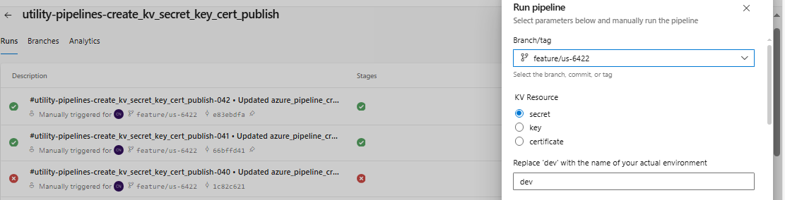

Sdkjfhsddfjhkesuhrfjnb

**kv-scv-intdevshared**

**#utility-pipelines-create_kv_secret_key_cert_publish-050 • Merged PR 4563: added expiry date to KV secret and key**

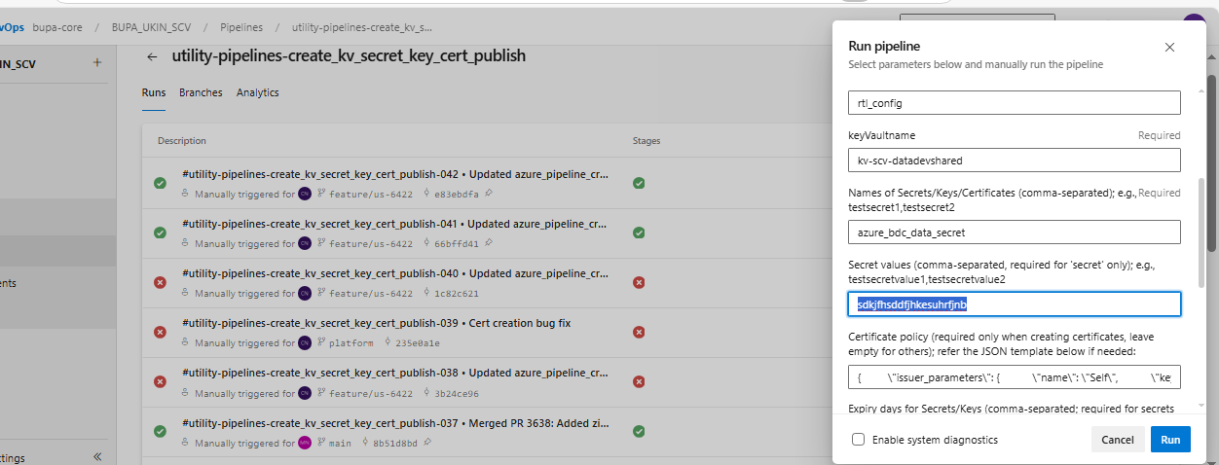

key-Azuredatafactorydbvalue ---dsfhsakdhfkdhfdff

azurebdcdatasecret,azurebdcdatasecret2

| key-Azuredatafactorydbvalue | <https://kv-scv-intdevshared.vault.azure.net/secrets/key-Azuredatafactorydbvalue/525ea31ea2d24274a9d1ab681d2338c8>

key-Azuredatafactorydbvalue(Keyvaultname)-🡪 525ea31ea2d24274a9d1ab681d2338c8 (Version)

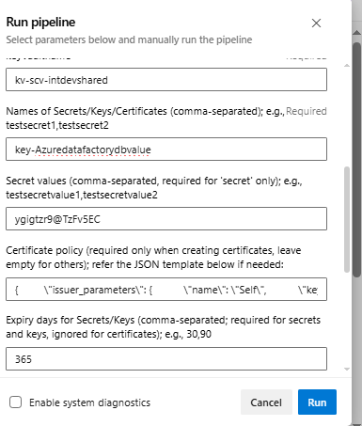

key-Azuredatafactorydbvalue | <https://kv-scv-intdevshared.vault.azure.net/secrets/key-Azuredatafactorydbvalue/a734b8bd5ad64fdfbedd9a9ac5e25ea7>

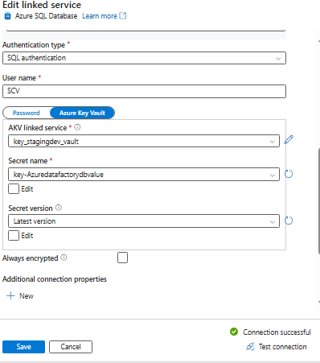

https://kv-scv-intdevshared.vault.azure.net/

key-Azuredatafactorydbvalue | <https://kv-scv-intdevshared.vault.azure.net/secrets/key-Azuredatafactorydbvalue/900ad64f76ea47b9b23c5234619585a3>

|-----------------------------------------------------------------------------------------------------------------------------|

| kvs-Azuredatafactorystagingdbvalue | <https://kv-scv-intdevshared.vault.azure.net/secrets/kvs-Azuredatafactorystagingdbvalue/3468e41c213443bc8d639b1b26c7e4a2> | 2026-03-06T15:23:03Z | Created |

|-----------------------------------------------------------------------------------------------------------------------------|